**HOME SCREEN**

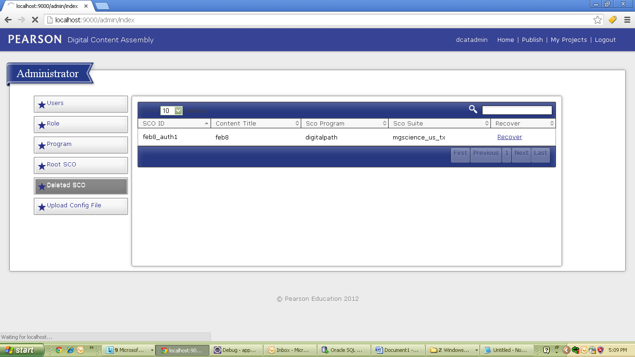

On clicking ”Recover” link, we get confirmation message if we want to continue or not:

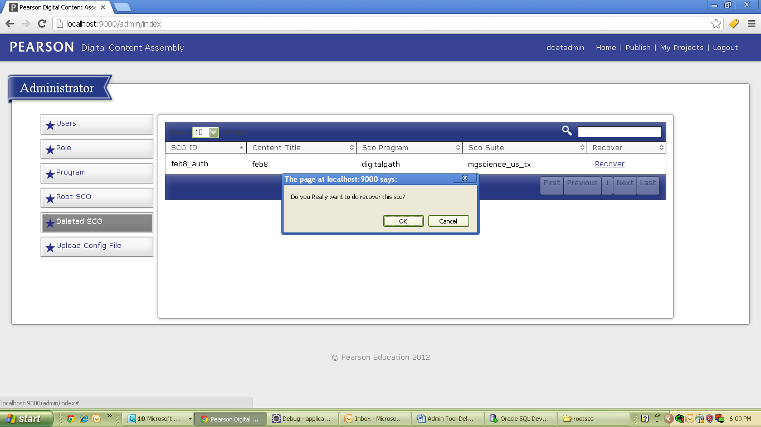

After successful recovery of SCO we get “Success” Message.

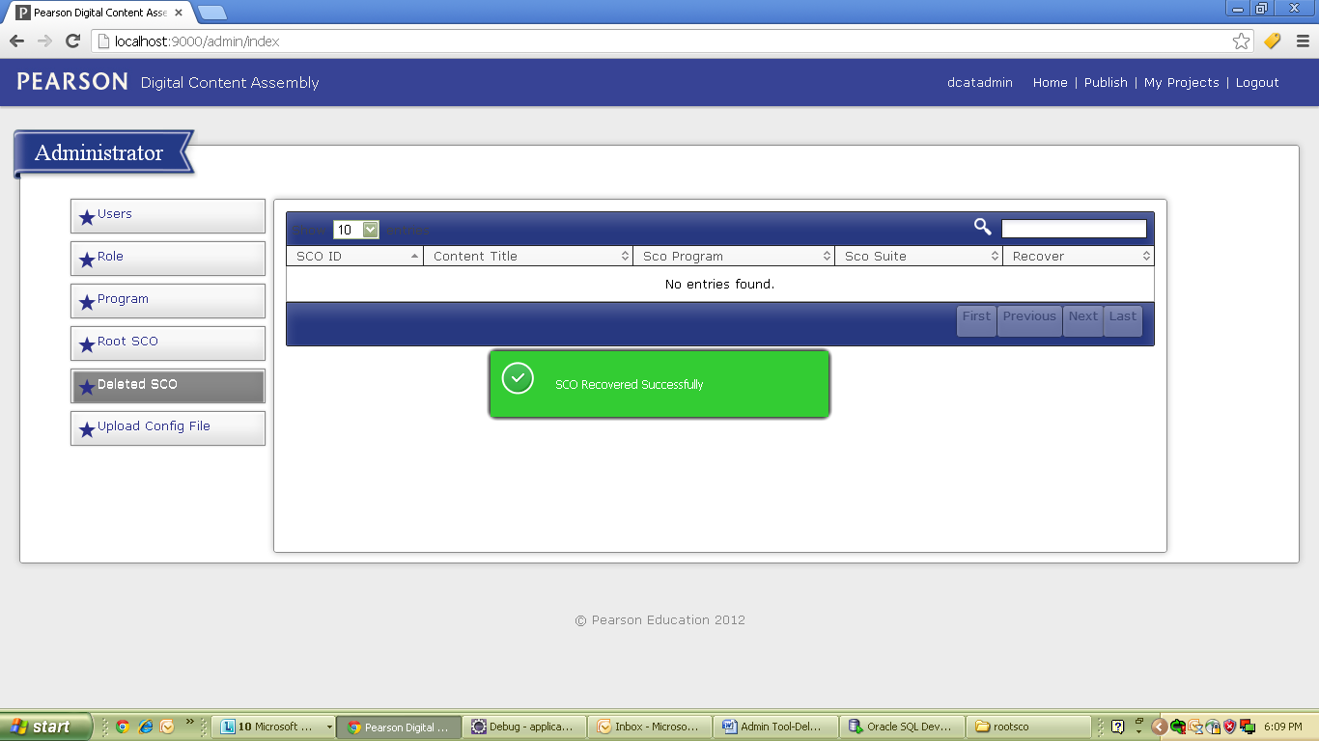

On unscucesful recovery of SCO-error message.